4 x 4 Low Telltale for MSOS and non-MSOS Vehicles – CGEA1.3

Functional Description

The purpose of the 4 x 4 Low telltale is to inform the driver that the vehicle is operating in four wheel drive Low mode.

The 4x4 Low telltale correlates the AwdLoLamp_D_RqDsply signal, the module configuration, and the Operational Mode to illuminate or extinguish the 4x4 Low telltale (non_MSOS vehicles). Alternatively, for MSOS vehicles, the 4x4 Low telltale correlates the 4x4 LOW hardwired input, the 4x4 HIGH hardwired input, the bulb_proveout_timer, and the Operational_Mode to illuminate or extinguish the 4x4 Low telltale .

The 4x4 Low telltale shall provide an iconic representation that will illuminate or extinguish to inform the driver whether they are in 4x4 mode or some other mode.

This STSS is only used for programs with both non-MSOS and MSOS 4 wheel drive systems. At the time of this release P558 is the only CGEA1.3 program known to have the MSOS feature.

Interfaces

Interface Context Diagram (I/O Block Diagram)
Figure 1: 4x4 Low Indication
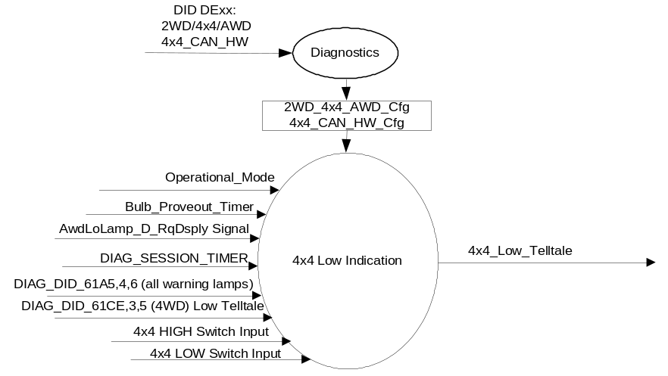

Inputs

      - INTERNAL:
            - 2WD_4x4_AWD_Cfg
            - 4x4_CAN_HW_Cfg
            - DIAG_SESSION_TIMER
            - Operational_Mode
            - Bulb_Proveout_Timer
            - DIAG_DID_61CE,3,5 (4WD) Low Telltale
            - DIAG_DID_61A5,4,6 (all warning lamps)
            - ETM_Bulb_Check_State
            - Self_Test_Entry_Bulb_Check_Timer
      - MUX message on the HS CAN Bus from HS_4x4CM

- AwdLoLamp_D_RqDsply Signal

ID | Size  (bits) | Detail | Units | Res. | Offset | State Encoded | Min. | Max.
AwdLoLamp_D_RqDsply | 2 |  | SED | 1 | 0 |  | 0(0x0) | 3(0x3)
 |  | Off |  |  |  | 0x0
 |  | On |  |  |  | 0x1
 |  | Flash |  |  |  | 0x2
 |  | Not_Used |  |  |  | 0x3

Outputs
- 4x4_Low_Telltale, which is used to control the state of the LED.

Function/Performance

Operational Modes

Mode | Differentiating Vehicle Conditions
Sleep Mode | 4x4 Low Telltale OFF
Limited Mode | 4x4 Low Telltale OFF
Normal Mode | 4x4 Low Telltale ON/OFF
Crank Mode | 4x4 Low Telltale ON/OFF

Voltage Levels

Refer to the Cluster Features table located in the Operational Modes and Voltage Range Strategies section in this SPSS

Human-Machine Interface

Visual

Indicator Graphics / Display Format
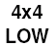

For actual symbol definition refer to the Ford Approved Symbols List Abbreviations section which is controlled/accessed by RQT-001301-003514 (Legacy 03-0685) ARL. 4L may be substituted for 4x4 LOW symbol at the request of the program and is also defined in the Ford Approved Symbols List Abbreviations section.

Indicator Color Coordinates

Amber - Reference SDS IH-0001/IS-0379

Indicator Characteristics

LED - 4x4 Low Telltale

Audio

None.

System Accuracy

The 4x4_Low_Telltale shall change the state of the Telltale within 100msec of a state change as indicated in the state matrix reference 1.3.5.1 Subsystem Algorithm Flowchart / State Diagram.

Operation: Performance and Functional

Subsystem Algorithm Flowchart / State Diagram

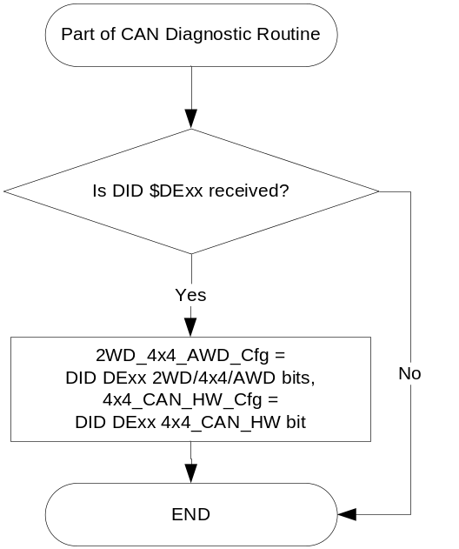

- State Matrix for TELLTALE_4X4_LOW
Operational_ mode | 2WD_ 4x4_ AWD_ cfg | 4x4_CAN_ HW_Cfg | ETM Bulb_ Check_State | DIAG_ SESSION_ TIMER | Self_Test_ Entry_Bulb_ Check_Timer | DIAG_DID_61CE, 3,5  [(4WD) Low Telltale] | DIAG_DID_61A5,4,6  (all warning lamps) | Bulb_ Proveout_ Timer | 4x4 HIGH_50msec  debounced switch state | 4x4 LOW_50msec  debounced switch state | AwdLoLamp_ D_RqDsply | 4x4_Low_  Telltale
Normal or  Crank | 4x4 | X | X | Not Active | X | X | X | Active | X | X | X | ON
Normal or  Crank | 4x4 | X | ON (0x1) | Not Active | X | X | X | X | X | X | X | ON
Normal or  Crank | 4x4 | CAN | X | Not Active | X | X | X | X | X | X | ON (0x1) | ON
Normal | 4x4 | CAN | X | Active | Not Active | Not Received | Not Received | X | X | X | ON (0x1) | ON
Normal | 4x4 | HW | OFF (0x0) | Not Active | X | X | X | Expired | Active (GND) | Active (GND) | X | ON
Normal | 4x4 | HW | OFF(0x0) | Not Active | X | X | X | X | Active (GND) | Inactive (OPEN) | X | OFF
Normal | 4x4 | HW | OFF (0x0) | Not Active | X | X | X | Expired | Inactive (OPEN) | Active (GND) | X | OFF
Normal | 4x4 | HW | OFF (0x0) | Not Active | X | X | X | Expired | Inactive (OPEN) | Inactive (OPEN) | X | OFF
Normal | 4x4 | HW | OFF (0x0) | Active | Not Active | Not Received | Not Received | Expired | Active (GND) | Active (GND) | X | ON
Normal | 4x4 | HW | OFF(0x0) | Active | Not Active | Not Received | Not Received | X | Active (GND) | Inactive (OPEN) | X | OFF
Normal | 4x4 | HW | OFF (0x0) | Active | Not Active | Not Received | Not Received | Expired | Inactive (OPEN) | Active (GND) | X | OFF
Normal | 4x4 | HW | OFF (0x0) | Active | Not Active | Not Received | Not Received | Expired | Inactive (OPEN) | Inactive (OPEN) | X | OFF
Normal | 4x4 | X | X | Active | Not Active | Not Received | Not Received | Active | X | X | X | ON
Normal | 4x4 | X | ON (0x1) | Active | Not Active | Not Rectived | Not Received | X | X | X | X | ON
Normal | 4x4 | X | X | Active | X | ON (0x1) | X | X | X | X | X | ON
Normal | 4x4 | X | X | Active | X | X | ON (0x1) | X | X | X | X | ON
Normal | 4x4 | X | X | Active | Active | X | X | X | X | X | X | ON
All Other Cases |  |  |  |  |  |  |  |  |  |  |  | OFF

X=Don’t Care
Not Received = The state when a DIAG_SESSION_TIMER is active and the DID has not been received

Operation Description (supports algorithm flowchart /state diagram)

Function Safety Classification (EMC)

Class B

Memory Storage
Parameter Name | Description | Value at  Battery Connect | Value at  Module Wake-up
4x4_Low_Telltale | Used to control the state of the LED | OFF (0x0) | OFF (0x0)
AwdLoLamp_ D_RqDsply | CAN signal sent from 4x4CM. | 0 (0x0) | 0 (0x0)
DIAG_DID_61CE, 3, 5  [(4WD) Low Telltale] | Warning Lamp "B" Status byte 3 bit 5  Four Wheel Drive (4WD) Low Telltale | Inactive (0x0) | Inactive (0x0)
DIAG_DID_61A5,4,6 (all warning lamps) | Indicator Lamp Control 2, byte 4, bit 6 (all warning lamps) | 0 (0x0) | 0 (0x0)
ETM_Bulb_Check_State | State indicator for warning bulb in ETM | OFF (0x0) | OFF (0x0)
2WD_4x4_AWD_Cfg | State indicator for feature presence controlled via CAN at EOL at VO plant. | Use Stored Value | Use Stored Value
4x4_CAN_HW_Cfg | State indicator as to whether 4x4 states are received via CAN or HW to IPC. | Use Stored Value | Use Stored Value
Operational_Mode | 4 state indicator for cluster operational mode | Limited | Limited, Normal or Crank

Parameter Name | Description | Value at  Battery Connect | Value at  Module Wake-up
DIAG_SESSION_TIMER | Timer used to time-out a diagnostic session | Not Active | Not Active
Bulb_Proveout_Timer | Internal command directing proveout | Not Active | Not Active
Self_Test_Entry_Bulb_Check_ Timer | Timer used in diagnostic session to do a self check of telltales | Not Active | Not Active

Prove Out

3.0 +/- 0.1 seconds as per bulb prove out section. Cluster controls prove out. No DTCs shall be logged while in Prove Out.

Reconfigurable Telltale

No.

Message Center Msg

None

Error Handling

Missing Message Strategy

The signals will be declared missing as per the Diagnostics section of this SPSS.

DTCs states and history will be determined as per the Diagnostics section of this SPSS.
If the 2WD_4x4_AWD configuration is not 4x4 (01), OR if the 4x4_CAN_HW configuration is not CAN, the cluster shall never log a missing message DTC due to this feature.

Diagnostics

Self Test

Bulb illuminated during self test as per Self_Entry_Bulb_Check_Timer

Engineering Test Mode

Reference section “Dealer / Engineering Test Mode (ETM)”.

Part II Performance

DID $DExx
Block  Num | Block Description | Size (bits) |  | Byte(s) | Bits | State: Description | "0" | "1" | Default | Comments/  Information
PACKETED BLOCKS
$xx | Option Content (B&A) |  |  | * | 2 | 2WD/4x4/AWD | encoded | encoded | 4x4
 |  |  |  |  |  | 00 - 2WD | encoded | encoded
 |  |  |  |  |  | 01 - 4x4 | encoded | encoded
 |  |  |  |  |  | 10 - AWD | encoded | encoded
 |  |  |  | * | 1 | 4x4_CAN_HW | Hardwired | CAN | CAN | Set to Hardwired for MSOS vehicles only.
*Byte and bit location to be identified in Part II Specification for this cluster

DIDs
Number | PID / CommonID Name | PID Type
61CE,3,5 | Warning Lamp "B" Status byte 3 bit 5  Four Wheel Drive (4WD) Low Telltale | Bit Mapped
61A5,4,6 | Indicator Lamp Control 2, byte 4, bit 6 (all warning lamps) | Bit Mapped

Supported Diagnostic Trouble Codes (DTCs)
DTC | Description | When Logged
C10200 | Lost Communication with Transfer Case Control Module | Message missing for more than 5 seconds and 4x4_CAN_HW_Cfg = CAN

Reference Specification

FO-0007 FOUR WHEEL DRIVE MODE DISPLAY
FO-0008 FOUR WHEEL DRIVE FAULT INDICATOR

IS-0001 WARNINGS/INDICATORS/DISPLAYS PROVEOUT
IS-0046 INSTRUMENTATION MATERIAL RESISTANCE TO CLEANING
IS-0052 OPERATING VOLTAGES - FUNCTIONAL/PERFORMANCE
IS-0069 FUNCTIONAL IMPORTANCE CLASS
IS-0324 WINDSHIELD & OTHER REFLECTIONS
IS-0327 WARNING INDICATOR EVALUATION
IS-0329 FLICKERING OF LAMPS
IS-0379 NORTH AMERICAN WARNINGS AND INDICATORS STRATEGY

IL-0017 TELLTALE AND INTERIOR ILLUMINATION COLOR
IL-0021 CRAFTSMANSHIP - DISPLAYS
IL-0023 CLARITY/LEGIBILITY/READABILITY
IL-0025 INTERIOR ILLUMINATION INTENSITY
IL -0027 VISUAL CONTRAST
IL -0043 OPERATIONAL ENVIRONMENT FUNCTIONALITY
IL -0045 COLOR
IL -0047 TELLTALE; INDICATOR AND DISPLAY LIGHT INTENSITY
IL -0048 ILLUMINATION ACCEPTABILITY

03-0661 PLACEMENT: CONTROL AND DISPLAY LOCATIONS
03-0662 PLACEMENT: LOGICAL GROUPING FUNCTION AND USAGE
03-0664 PLACEMENT: DOWN VISION TO COMPONENTS WITH HIGH VISUAL DEMAND
03-0665 PLACEMENT: EXPECTED LOCATIONS OF CONTROLS AND DISPLAYS VDS
03-0670 INTERIOR VISIBILITY
03-0671 INTERIOR VISIBILITY: REFLECTIONS FROM COMPONENTS & SURFACES
03-0672 INTERIOR VISIBILITY: REFLECTIONS IN DISPLAYS
03-0673 INTERIOR VISIBILITY: VISUAL OBSCURATIONS
03-0674 INTERIOR VISIBILITY: ILLUMINATION CONTROLS / DISPLAYS
03-0675 INTERIOR VISIBILITY: VEILING GLARE
03-0677 INTERIOR VISIBILITY: SUNLIGHT WASHOUT
03-0681 IDENTIFICATION: CHARACTER AND SYMBOL SIZE
03-0682 IDENTIFICATION: LEGIBILITY
03-0685 IDENTIFICATION: SYMBOLS, ABBREV FOR CONTROL
03-0721 LOGIC OF OPERATION: OPERATIONAL STEREOTYPES
03-0722 LOGIC OF OPERATION: INTERPRETATION
03-0723 LOGIC OF OPERATION: USE OF SYSTEMS WITH VISUAL DISPLAYS

Revision History

SPSS Module Revision History

Revision Level | Name | Change Description | Date
1.0 | J. Blatchford | Initial Release. At the time of this release 2017 P558 is the only CGEA1.3 program known to implement MSOS 4x4. | 3/10/2014
1.1 | A. Venuturupalli  S. Watkins | Minor update to Table 1.1 to remove overlapping and conflicting conditions.  Per Denso Q&A #508 P558 MY17 | 5/5/2015

